1a) Data Types:

Write a Java program to store and display the following details of a household:

Number of family members – integer
Water consumed in litres – decimal value
House number – integer
Water usage status – character
Use appropriate Java data types for each value and display all the details.

public class Hackathon1{
public static void main(String[] args){
int familyMembers = 4;
double waterConsumed = 250.55;
int houseNumber = 111;
char waterStatus = 'C';

System.out.println("Household Details");
System.out.println("House Number: " + houseNumber);
System.out.println("Number of Family Members: " + familyMembers);
System.out.println("Water Consumed (Litres): " + waterConsumed);
System.out.println("Water Status: " + waterStatus);
}
}

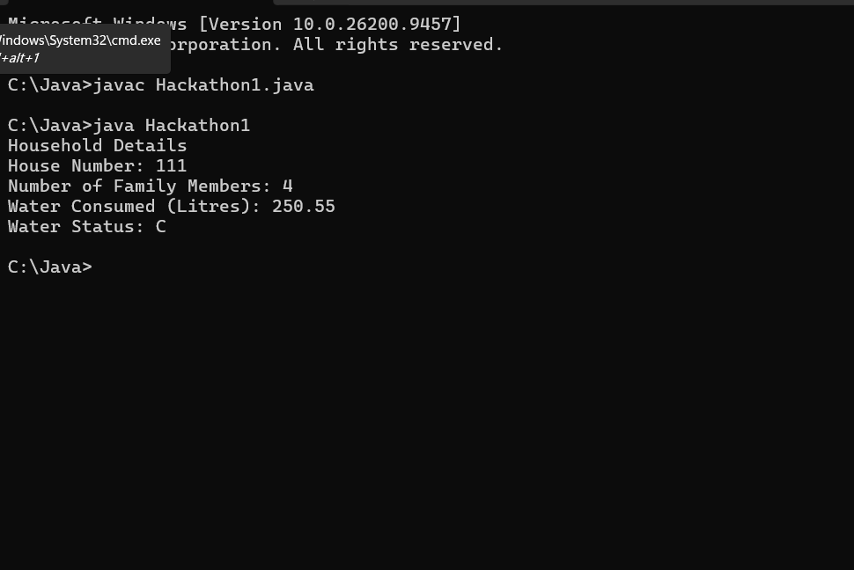

1b) If-Else Condition:

Write a Java program to calculate the water bill based on water consumption. Read the water consumption in litres.

If consumption is 500 litres or less, the bill is Rs.100.
If consumption is more than 500 litres, the bill is Rs.200.
Use an if-else statement and display the water bill.

import java.util.Scanner;

public class Hackathon2 {
public static void main(String[] args) {
Scanner scanner = new Scanner(System.in);

System.out.print("Enter water consumption in litres: ");
double consumption = scanner.nextDouble();

int bill;

if (consumption <= 500) {
bill = 100;
} else {
bill = 200;
}

System.out.println("The water bill is: Rs. " + bill);

scanner.close();
}
}

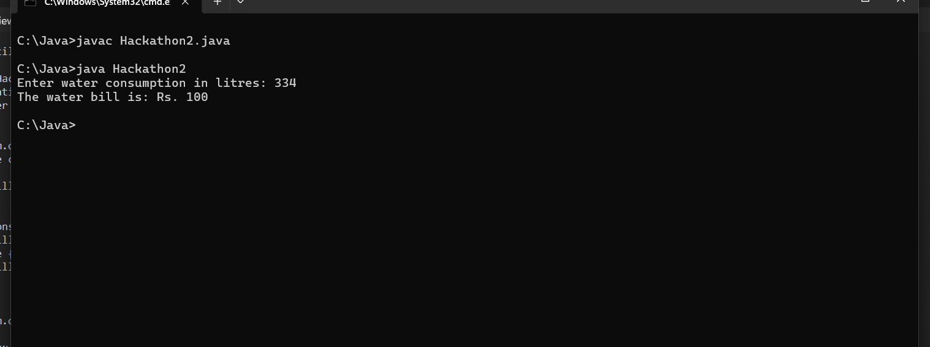

1c) Methods:

Write a Java program to calculate the total water consumption of a household using a method.

Create the following method:

calculateTotal(int morningUsage, int eveningUsage)
The method should return the total water consumption. Read the morning and evening water usage from the user, call the method, and display the total consumption.

import java.util.Scanner;

public class Hackathon3 {

public static int calculateTotal(int morningUsage, int eveningUsage) {
return morningUsage + eveningUsage;
}

public static void main(String[] args) {
Scanner scanner = new Scanner(System.in);

System.out.print("Enter morning water usage (litres): ");
int morning = scanner.nextInt();

System.out.print("Enter evening water usage (litres): ");
int evening = scanner.nextInt();

int totalConsumption = calculateTotal(morning, evening);

System.out.println("Total water consumption: " + totalConsumption + " litres");

scanner.close();
}
}
